Conceptual and Feasibility Model Design

S2019

|  |  |  |  |
| --- | --- | --- | --- |
| Lab Section: | 1 | Group: | 17 |

# Conceptual Design (High-Level)

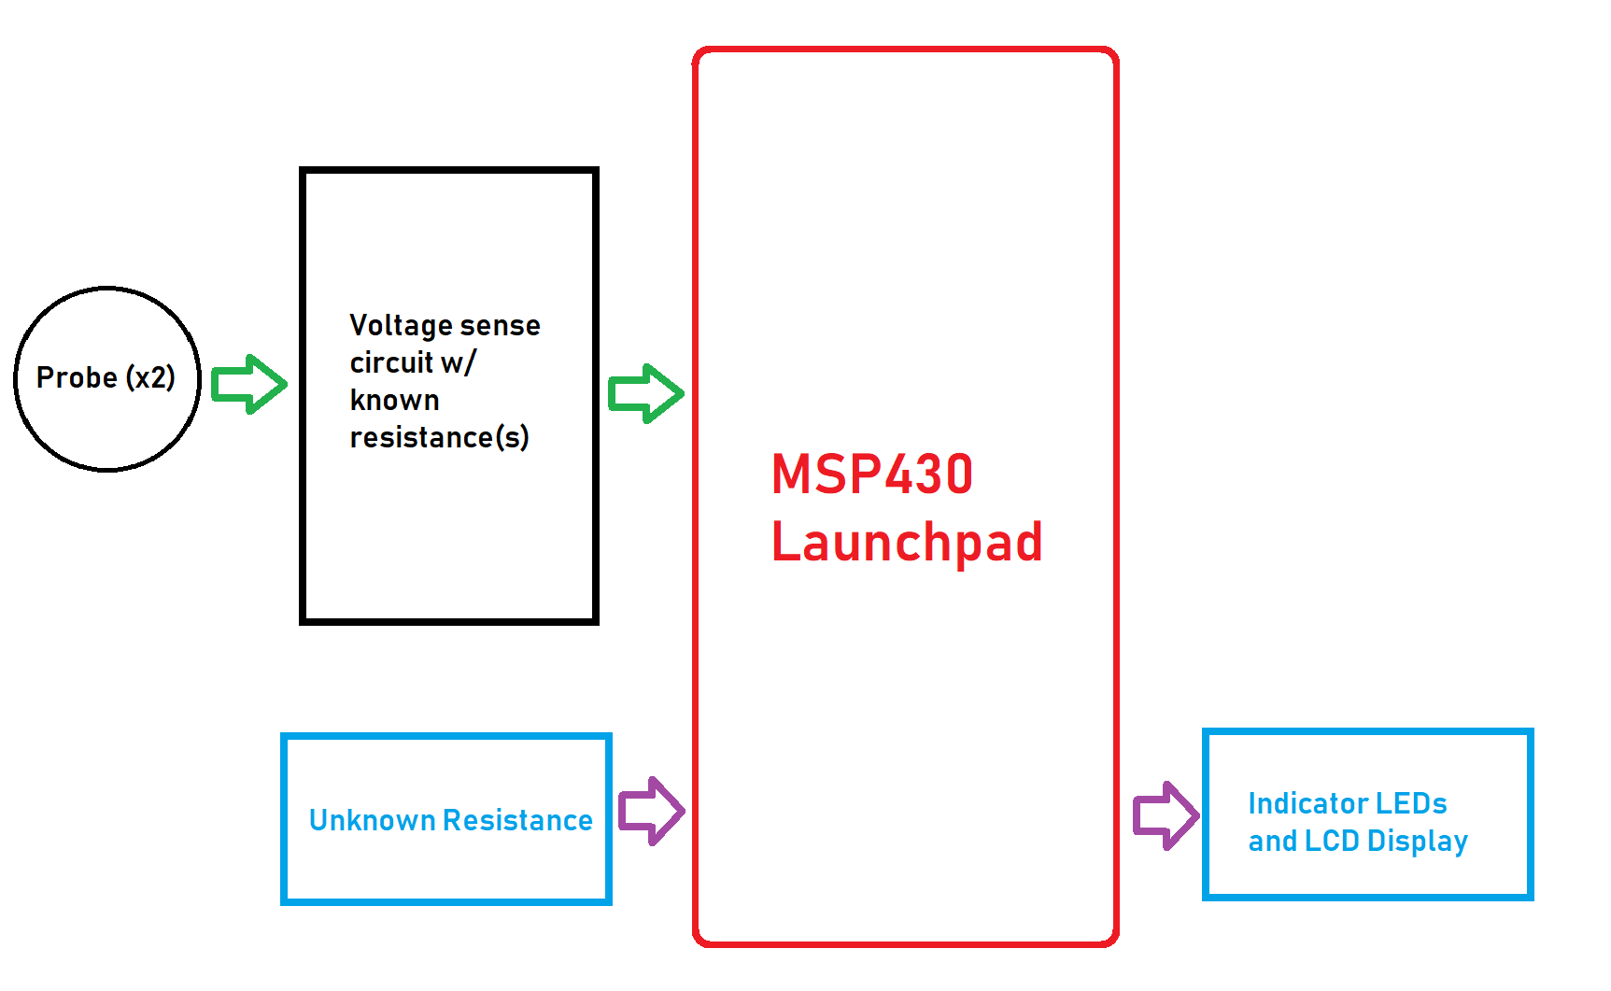

Figure : Resistance Sensor High Level Block Diagram

## Project Design Requirements

In order to measure the success of the resistance sensing project, the project must satisfy the following 4 requirements:

1. The system must be able to successfully determine the resistance of an unknown object within a certain degree of precision and accuracy
2. The system must relay information in a clear and concise format to the user
3. The system must be able to automatically adjust its resistance range according to provided object
4. The latency between connecting probes to the object and the output of the information to the user must be relatively low

## Project Sensors

The number sensors required for the resistance measuring device is low. In terms of sensors, we just need two probes that of which is similar to those found on a DMM. This is to allow our voltage sensing circuit to run through the unknown resistance and to perform the necessary calculations to determine resistance values. There “sensors” allow current flow across the unknown resistor which therefore causes a voltage drop. This voltage drop is an analog signal which can be measured via the MSP430 onboard ADC.

## Project Actuators and Indicators

In terms of actuators, there is none as the resistance sensing system is simply relaying information to the user and not controlling any external devices. There are, however, numerous indicators one of which is the LCD display which is used to output the resistance values in addition to the SI units of the unknown resistance. In addition to the LCD display, there are indicator LEDs which indicate whether a stable connection has been made (with the probes to the unknown resistance), whether the device is powered and if an error has occurred (e.g. unknown resistance outside range of system).

## Project Software Interfaces

In order to read the voltage from the resistance sensing circuit, it is necessary to use an ADC to gather and interpret data. In addition to this, GPIO functions to control indicators such as LEDs and to control the 8-to-1 mux select lines to switch between reference resistors. The majority of the information processed via software would be through the ADC and displayed via the LCD display onboard the MSP430 Launchpad. Finally, the raw values of the ADC must be averaged in a way that preserves accuracy but at the same time limits the input noise.

## Project User Interfaces

The user-input for the resistance sensing module would be an object with unknown resistance placed in between the two probes. Because the resistance sensor is auto-ranging, there should be little to no interference from the user other than possibly a reset button however the MSP430 Launchpad has an onboard reset button which may be utilized. An indicator LED would light up if a successful connection has been made and the LCD display will output the measured resistance with SI units. Any error that may have occurred would either be displayed on the LCD display or indicator LED.

## Project Testing Methodology (brief)

To validate resistance readings, we may simply verify the module against a DMM. In addition to this we may also find it useful to use variable resistances or potentiometers to demonstrate precision and accuracy of the resistance sensing module. Initially when testing the standalone ADC to measure voltage drops, we may also find it useful to verify readings against an oscilloscope. Ideally, the tester would observe little fluctuations in a static resistor and resistance readings that don’t differ too much from indicated resistance values (e.g. from DMM or colour bands).

# Project Feasibility Model Design and Software Flowchart (High-Level)

A simplified example is shown in Figure 2. **Replace this figure with a high-level block diagram of your system.**

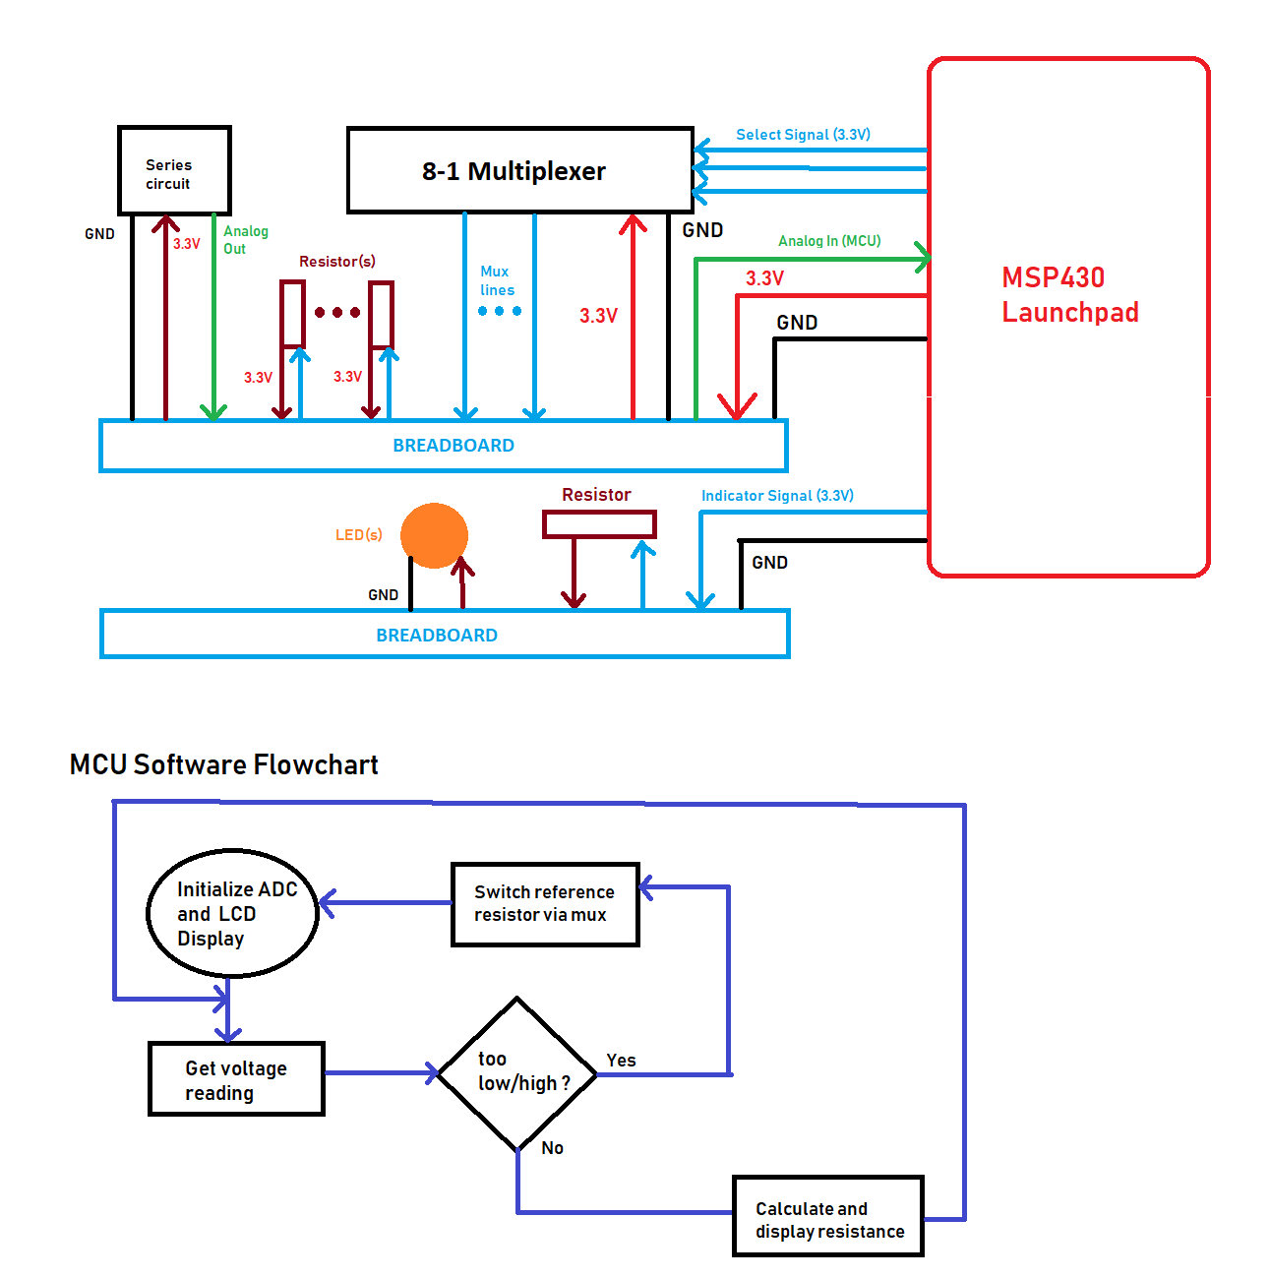

Figure : Simple Sketch of a Feasibility Model Design and a Software Flowchart

* List what modules (including quantities) are needed from the ECE 298 Parts spreadsheet for your Feasibility Model Design
* List the internal MCU resources needed to interface to the Modules (e.g. ADC, timer, etc.)
* List the MCU GPIO pins needed to connect MCU resources (e.g. ADC, timer, etc.) to the modules

Hardware Components needed:

* MCP430 Launchpad (x1)
* 8-to-1 Multiplexer (x1)
* Red LED (x1)
* Green LED (x1)
* Yellow LED (x1)
* 100, 500, 1k, 10k, 100k, 500k, 1M resistors

In terms of internal resources, it is necessary for the resistance sense module to use ADCs and GPIOs. In addition to this, timers may be used to sample and average data from the ADC to reduce noise in the system.

MCU Pins:

* P8.1 – ADC
* P2.7 and P2.5 - GPIO